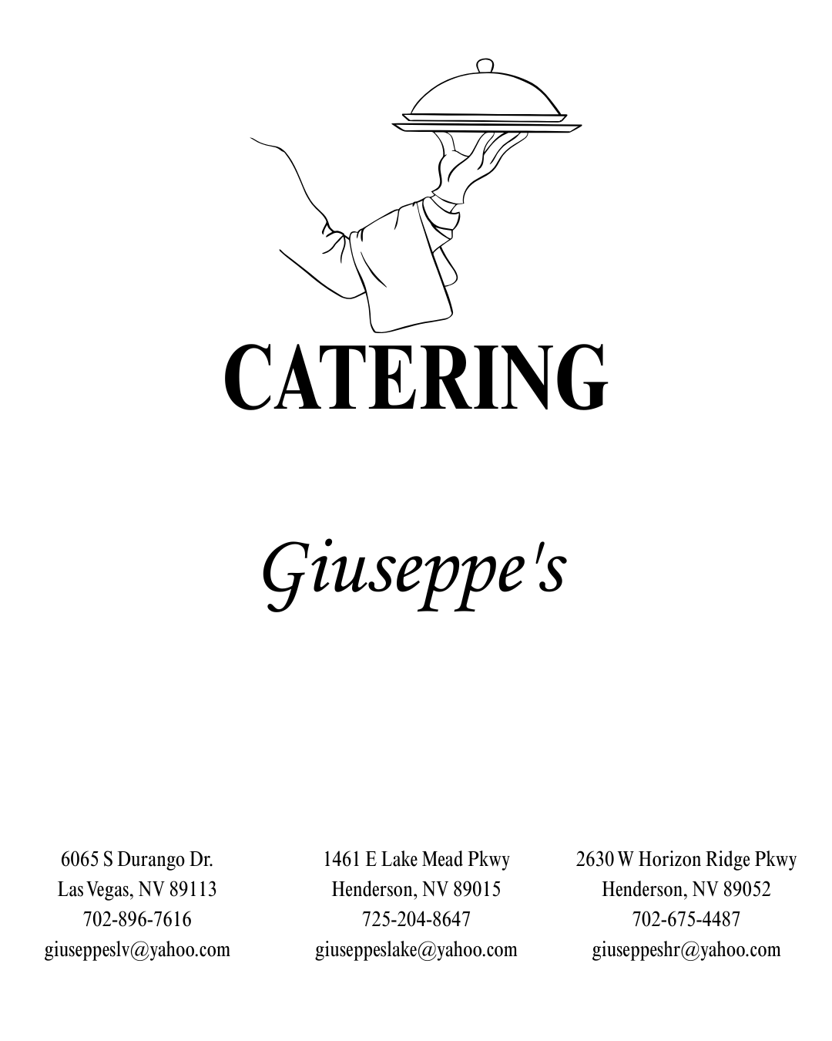

Sit-Down Dinner

**Ribeye Steak 60**

Choice boneless 16oz. Ribeye Steak, served with potato & vegetable

**London Broil 33**

Tender slices of beef in au jus, served with potato & vegetable

**Chicken Parmigiana 33**

Lightly breaded chicken topped with mozzarella cheese and tomato sauce, served with fettuccini pasta

**Chicken Marsala 33**

Sauteed chicken breast in Marsala wine sauce, served with fettuccini pasta

**Mezzi Rigatoni and Meatballs 30**

Mezzi Rigatoni pasta with two homemade meatballs in tomato sauce

**Spaghetti with Meat Sauce 30**

Spaghetti pasta topped with our meat sauce

**Lasagna 33**

House made lasagna smothered in our tomato sauce

**Mezzi Rigatoni and Shrimp Piccata 33**

Mezzi Rigatoni pasta topped with shrimp in lemon wine sauce

**Salmon 35**

Served with potato and vegetable

Includes:

House Salad or Caesar Salad

Italian Bread, Dessert

Soft Drinks, Coffee, Tea

**Added to a Sit Down**

Choice of Two Appetizers $18.00 per person

Any Additional Appetizers $9.00 per person

Children 12 and under is 25% off the per person price

20 person minimum

20% Gratuity- Plus Sales Tax

$125 Fee (Set Up, Tear Down, Linen)

Dinner Buffet

**Sirloin Beef with Mushrooms in Au Jus**

**Chicken Marsala**

**Chicken Parmigiana**

**Chicken Francaise**

**\*Chicken Saltimbocca**

**Stuffed Chicken over Rice** Stuffed with Ricotta, Spinach, Parmesan, Capocollo

**Breaded Chicken Breast with Peppers & Onions in a Wine Glaze**

**Breaded Pork Chops**

**\*Roasted Pork Loin**

**Italian Sausage with Peppers & Onion**

**Eggplant Lasagna**

**Mezzi Rigatoni Bolognese** Bacon, Vegetable, and Cream

**Breaded Alaskan Pollock**

**Baked Cod** over Spinach and Orzo

Includes:

Italian Bread

House Salad or Caesar Salad

Mezzi Rigatoni Pasta, Tomato Sauce or Alfredo Sauce

Mashed Potatoes, Roasted Potatoes or Scallop Potatoes

Vegetable

Dessert

Soft Drinks, Coffee, Tea

Two Entrée Selection $37.99 per person

Add an additional meat entrée for an additional $9.00 per person

*Additional $3.00 per person

**Added to a Buffet**

Choice of Two Appetizers $18.00 per person

Any Additional Appetizers $9.00 per person

Children 12 and under is 25% off the per person price

20 person minimum

20% Gratuity- Plus Sales Tax

$125 Fee (Set Up, Tear Down, Linen)

Continental Breakfast

**Seasonal Fresh Fruit Platter**

**Assorted Muffins**

**Croissants & Danish**

**Yogurt**

**Assorted Cereal**

**Coffee, Tea, Orange Juice, Milk**

**$20.99 per person**

**~~~~~~~~~~~~~~~~~~~~~~~~~~~~~~~**

**Breakfast Buffet**

**Scrambled Eggs**

**Home Fry Potato**

**Sausage & Bacon**

**French Toast or Pancakes**

**Muffins & Danish**

**Coffee, Tea, Orange Juice, Milk**

**$25.99 per person**

20 Person Minimum

20% Gratuity- Plus Sales Tax

$125 Fee (Set Up, Tear Down, Linen)

Appetizer

**Italian Sausage with Peppers & Onions**

**Meatballs in Tomato Sauce**

**Mozzarella Sticks**

**Chicken Fingers Plain or BBQ**

**Eggplant Parmigiana**

**Fried Calamari**

**Stuffed Mushrooms**

**Bruschetta**

**Sheet Pizza- Two Toppings**

Soft Drinks not Included

Choice of Three Appetizers $30.99 per person

Any Additional Appetizer will be an additional $10.00 per person

**Platters**

**Insalada Caprese Platter $8.00 per person**

**Antipasto Platter $10.00 per person**

**Cheese Platter $8.00 per person**

**Relish Platter $8.00 per person**

20 Person Minimum

20% Gratuity- Plus Sales Tax

$125 Fee (Set Up, Tear Down, Linen)

Sit-Down Lunch

**Cran Feta Chopped Salad 26**

Chopped Romaine, chicken, cranberries, feta cheese and pecans tossed in out white balsamic dressing

**Seafood Salad 26**

Blend of mixed greens with Cajun shrimp crabmeat, egg, tomatoes, red onion tossed with our white balsamic dressing topped with parmesan cheese

**Italian Sausage Sandwich 26**

Italian Sausage, peppers and onion topped with Mozzarella cheese and tomato sauce

Served with fries.

**Fettucini Pomodoro 26**

Roasted Tomatoes, olive oil, garlic and fresh basil served with chicken

**Mezzi Rigatoni Italiano 26**

Chopped meatballs, sausage, green peppers and onions tossed in our tomato sauce

**Eggplant Parmigiana 26**

Sliced breaded eggplant with mozzarella cheese and tomato sauce, served with fettuccine pasta

**Mezzi Rigatoni Casserole 26**

Mezzi Rigatoni pasta topped with our meat sauce and tomato sauce and melted provolone cheese

**Chicken Parmigiana 26**

Lightly breaded chicken breast topped with melted mozzarella cheese and tomato sauce,

Served with fettuccine pasta

**Chicken Marsala 26**

Over capellini pasta

**Salmon 29**

Served with potato and vegetables

Includes:

House Salad or Caesar Salad

Italian Bread

Soft Drink, Coffee, Tea

Dessert $5.00 per person

**Added to a Sit Down**

Choice of Two Appetizers $18.00 per person

Any Additional Appetizers $9.00 per person

Children 12 and under is 25% off the per person price

20 person minimum

20% Gratuity- Plus Sales Tax

$125 Fee (Set Up, Tear Down, Linen)

Lunch Buffet

11-3

**Chicken Marsala**

**Breaded Chicken Breast with Peppers and Mushrooms in a Wine Glaze**

**Chicken Parmigiana**

**Chicken Francaise**

**Chicken Di Limone**

**Mini Meatballs in our Tomato Sauce**

**Sirloin Beef with Mushrooms and Au Jus**

**Italian Sausage with Peppers & Onions**

**Breaded Pork Chops**

**Breaded Alaskan Pollock**

**Baked Cod over Spinach and Orzo**

Includes:

Mezzi Rigatoni Pasta- Tomato Sauce

Vegetables

House Salad or Ceasar Salad

Soft Drink, Coffee & Tea

Two Entrée Selection $29.99 per person

Any Additional Appetizer will be an additional $9.00 per person

Dessert $5.00 per person

**Added to a Buffet**

Choice of Two Appetizers $18.00 per person

Any Additional Appetizers $9.00 per person

Children 12 and under is 25% off the per person price

20 person minimum

20% Gratuity- Plus Sales Tax

$125 Fee (Set Up, Tear Down, Linen)

Giuseppe Buffet

Mezzi Rigatoni Pasta with Tomato Sauce

Pizza, 2 Toppings

House Salad

**$25.00 per person**

Includes:

Soft Drink, Coffee, Tea

**Added to a Buffet**

Choice of Two Appetizers $18.00 per person

Any Additional Appetizers $9.00 per person

Meat Entrée $9.00 per person

Dessert $5.00 per person

Children 12 and under is 25% off the per person price

20 person minimum

20% Gratuity- Plus Sales Tax

$125 Fee (Set Up, Tear Down, Linen)

Liquor Menu

Packages

Domestic Drafts

House Wine

**$24**

Well Liquor

Domestic Drafts

House Wine

**$29**

Premium Liquor

**$39**

**Premium Liquor**

**Vodka:** Ketel one, Titos, Ciroc

**Gin:** Tanqueray, Bombay Sapphire, Hendricks

**Whiskey/Bourbon:** Crown Royal, Jameson, Makers Mark, Jack Daniels

**Scotch:** Johnnie Walker Black, Glenmorangie, Glenfiddich 12 yr

**Tequila:** Teremana, Patron

**Rum:** Bacardi, Captain Morgan, Malibu

Choose a:

**Open Bar**

Full open bar or house wines & draft beer, limited open bar fully paid by host

**Budget**

Host sets a budget and allows guests to enjoy an open bar or a limited open bar, once budget is hit, the host can then choose to raise the budget or close the bar tab, then the bar turns into a cash bar

**Cash Bar**

Guests pay for their own alcohol

20 person minimum

20% Gratuity- Plus Sales Tax

$125 Fee (Set Up, Tear Down, Linen)